**Confusion Matrix:** Confusion matrix is the n*n matrix where n is the no. of different class labels.

Example: For binary classification it would be 2*2 matrix.

For column we have actual values and for row we have predicted value.

Therefore,

M00 -> no. of elements which are predicted 0 and actually are 0

M01 -> no. of elements which are predicted 0 and actually are 1

M10 -> no. of elements which are predicted 1 and actually are 0

M11 -> no. of elements which are predicted 1 and actually are 1.

Confusion matrix can’t process probability scores.

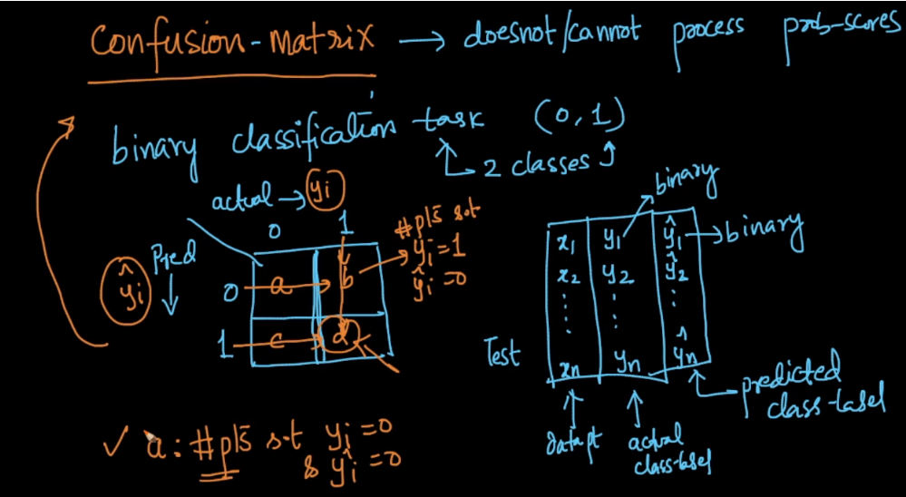

For Any model what we want that the of right production should be more or high, and therefore in confusion matrix the diagonal represent no. of points which are correctly classified.

Therefore for sensible model the principal diagonal should be large and off diagonal element should be small.

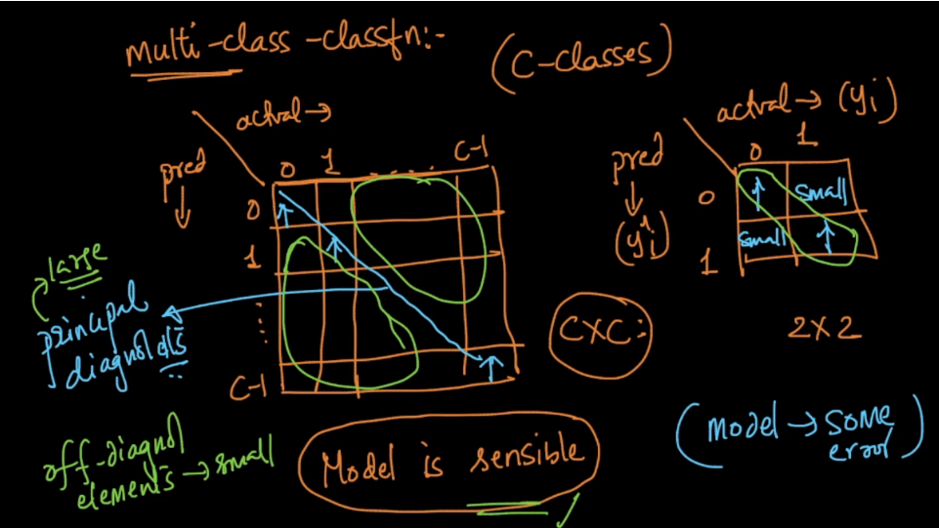

**Let’s know TP, FP, FN, TN.**

Cell which each of this term locate is shown in below figure. The way to remember is as follows.

Let’s take TP:

T -> represents whether the predicted value is correct.

P -> represents what is the predicted value.

Therefore TP represents the no. of points which are predicted positive and actually also they are positive.

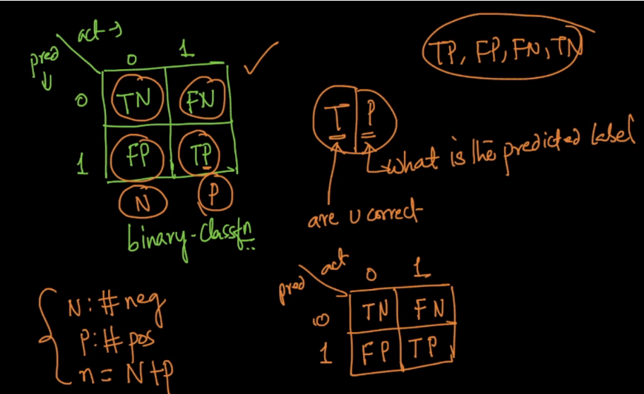

**Let’s define term TPR, TNR, FPR, FNR:**

Sum of values present in column 0 is N

And sum of values present in column 1 is P.

And N + P = n(total no. of datapoints).

Therefore

TPR(true positive rate) = TP / P -> It says what percentage of +ve values is predicted +ve(correct prediction percentage of +ve values.

TNR(true negative rate) = TN / N -> It says what percentage of -ve values is predicted -ve(correct prediction percentage of -ve values).

FPR(false positive rate) = FP / N -> It says what percentage of -ve values is predicted +ve(incorrect prediction percentage of +ve values.

FNR(false negative rate) = FN / P -> It says what percentage of +ve values is predicted -ve(incorrect prediction percentage of -ve values).

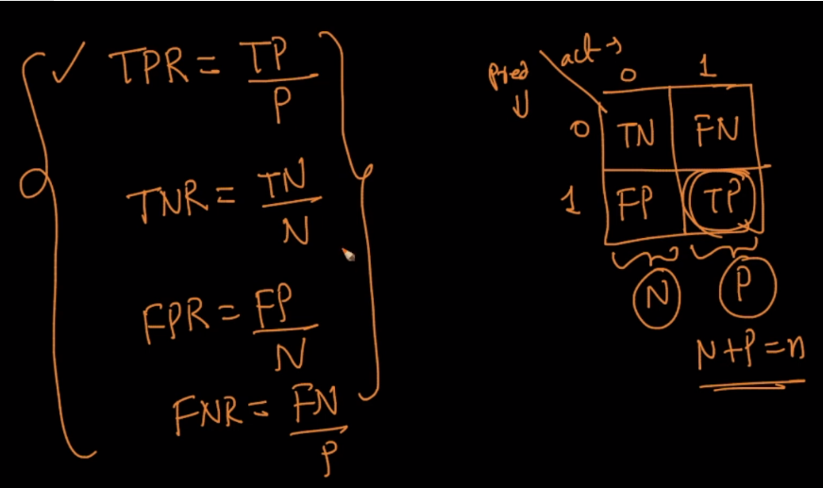

So now looking at just this 4 terms (TPR, TNR, FPR, FNR) we can say whether our model is sensible or dumb.

Our model is said to be sensible if TPR and TNR is high, and FPR and FNR is low, otherwise model is said to be dumb.

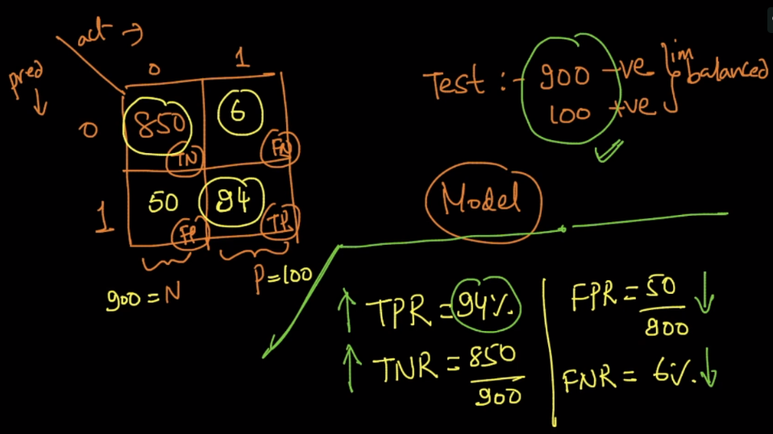

Below image shows example of dumb model where we are getting TPR as 0% and FNR as 100%, which is the worst case.

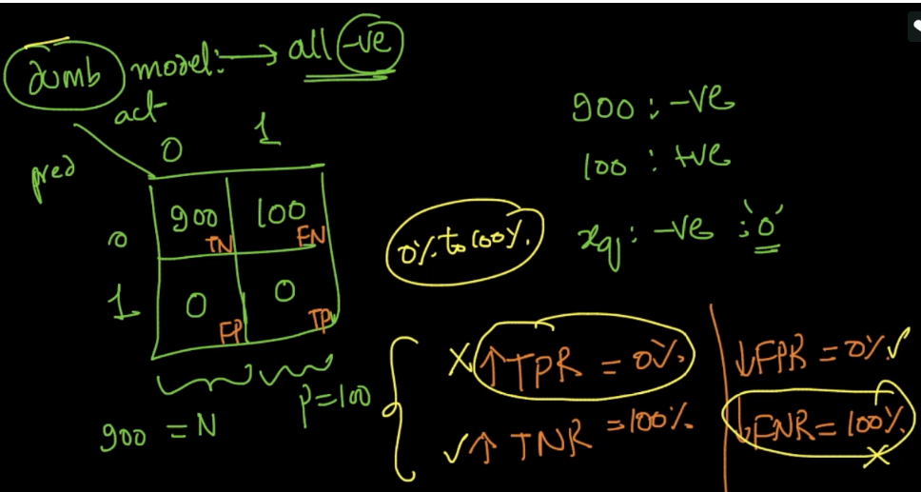

**Since here we have 4 terms, which term should be given more importance.**

It’s completely dependent on domain we are working.

Let’s say for cancer diagnosis, it’s very important to find that patient has cancer. It’s okay if patient has not cancer and it’s predicted as cancer because then the patient can for more powerful test to determine it, but if the patient has cancer and it’s predicted as not a cancer then it lead to very harmful results.

Therefore for Cancer diagonosis TPR should be very high and FNR should be very low.

And it’s okay if TNR is slightly high and FPR is slightly low.

Another example of criminal, it’s ok if criminal is declared as non-criminal, but it will be very bad if innocent person is declared as criminal. So in this case we want TNR to be very high and FPR should be very low.

